SIMATS ENGINEERING (SAVEETHA SCHOOL OF ENGINEERING)
Department of Computer Science and Engineering
CO3 ASSESSMENT TOOL 1 – Git & Docker Technical Assignment

Course Code: | CSA10 | Course Title: | Software Engineering
CO Assessed: | CO3 | Assessment: | Assessment Tool 1 – Git & Docker Technical Assignment
Weightage: | 20% | Total Marks: | 25
CO3 Statement: | Build full-stack applications with an emphasis on containerization, version control, and collaborative development
Student Name: | Ganeshwar S | Reg. No.: | 192421342
Date: | 14.08.26 | Duration: | 60 minutes

Code of Conduct
I Ganeshwar s/ 192421342 certify that this submission is my original work and that I have adhered to the guidelines specified for this assessment. I understand that any violation of academic integrity rules will result in disciplinary action.
Signature of the Student: Ganeshwar S

Evaluation Criteria | Excellent (4 Marks) | Good (3 Marks) | Satisfactory (2 Marks) | Needs Improvement (1 Mark)
Problem Analysis & Project Design(20%) | Clearly explains the problem statement, objectives, requirements, expected outcomes, and well-organized project structure with proper justification. | Good analysis and project structure with minor omissions. | Basic analysis and repository structure with limited justification. | Incomplete or unclear analysis and project organization.
Git Repository & Branching Strategy(20%) | Repository initialized correctly with appropriate branching strategy, clear workflow, and proper repository organization. | Repository and branching strategy are mostly correct. | Basic Git setup with limited branching implementation. | Incorrect or incomplete Git repository and branching strategy.
Version Control Workflow & Commit History(10%) | Demonstrates meaningful commits, branching, merging, synchronization, conflict resolution, and professional commit messages with clear history. | Most Git operations demonstrated correctly with good commit history. | Limited Git workflow and commit practices. | Poor workflow and inadequate commit history.
Docker Implementation(20%) | Well-designed Docker environment, Dockerfile, and Docker Compose configuration with clear explanation of services, networking, volumes, and dependencies. | Functional Docker implementation with minor issues. | Basic Docker implementation with limited explanation. | Incomplete or incorrect Docker implementation.
Deployment, Testing & Results(15%) | Application successfully deployed and tested with appropriate screenshots and evidence of successful execution. | Deployment completed with minor issues. | Partial deployment and testing demonstrated. | Deployment unsuccessful or insufficient evidence.
Documentation, Challenges & Future Enhancements(15%) | Professional report (10–15 pages) with diagrams, screenshots, references, discussion of benefits, challenges, and future improvements. | Good documentation with minor omissions. | Basic documentation with limited discussion. | Poor documentation and insufficient analysis.

Criteria | Mark
System Requirement Analysis (30%) | /5
Selection of Software Architecture (25%) | /5
Architecture Diagram and Component Design (20%) | /5
Component Interaction and Quality Attribute Analysis (15%) | /5
Architectural Justification and Technical Presentation (10%) | /5
TOTAL | /25

Table of Contents
1. Problem Analysis
2. Project Structure Design
3. Git Repository Initialization
4. Git Branching Strategy
5. Version Control Workflow
6. Commit History Analysis
7. Docker Environment Design
8. Dockerfile Development
9. Docker Compose Design
10. Container Deployment and Testing
11. Benefits of Git and Docker
12. Challenges and Improvements
Conclusion
References

1. Problem Analysis

1.1 Assigned Problem Statement
The assigned problem statement is: “Build full-stack applications with an emphasis on containerization, version control, and collaborative development.” To satisfy this brief with a concrete, demonstrable system, the chosen project is TaskFlow — a collaborative full-stack task management application that allows registered users to create projects, assign tasks to team members, track task status in real time, and comment on tasks. The project intentionally exercises every concept named in the CO3 statement: a multi-service full-stack codebase, Git-based version control with a formal branching strategy, and Docker-based containerization for reproducible, portable deployment.

1.2 Project Objectives
- Design and implement a full-stack web application using the MERN-style stack (MongoDB, Express.js, React, Node.js) with a real-time notification layer.
- Establish a disciplined Git version-control workflow that supports parallel, collaborative development across multiple contributors.
- Containerize every service of the application using Docker so that the entire stack can be built and run identically on any machine.
- Orchestrate the multi-container system using Docker Compose, including networking, persistent storage, and environment configuration.
- Demonstrate a complete DevOps-style loop: code → commit → branch → review → merge → containerize → deploy → test.

1.3 Functional Requirements
ID | Requirement | Description
FR-1 | User Authentication | Users can register, log in, and log out using JWT-based authentication.
FR-2 | Project Management | Users can create projects and invite team members to collaborate.
FR-3 | Task CRUD | Users can create, read, update, delete, and assign tasks within a project.
FR-4 | Status Tracking | Tasks move through To-Do, In-Progress, and Done states on a Kanban board.
FR-5 | Real-time Updates | Task changes are broadcast to all connected clients using Socket.IO.
FR-6 | Comments | Users can comment on individual tasks for asynchronous discussion.

1.4 Expected Outcomes
- A fully functional, containerized full-stack application that can be started with a single docker compose up command.
- A public Git repository with a complete, meaningful commit history and an auditable branching model.
- A reproducible deployment pipeline that eliminates “it works on my machine” environment issues.
- A technical report documenting design decisions, workflows, and evidence of successful execution.

2. Project Structure Design
The repository is organised as a monorepo containing an independently deployable client, server, and reverse-proxy configuration. Separating the frontend and backend into distinct folders — each with its own Dockerfile and package.json — allows each service to be built, versioned, and containerized independently while still being coordinated centrally through a single docker-compose.yml at the project root.
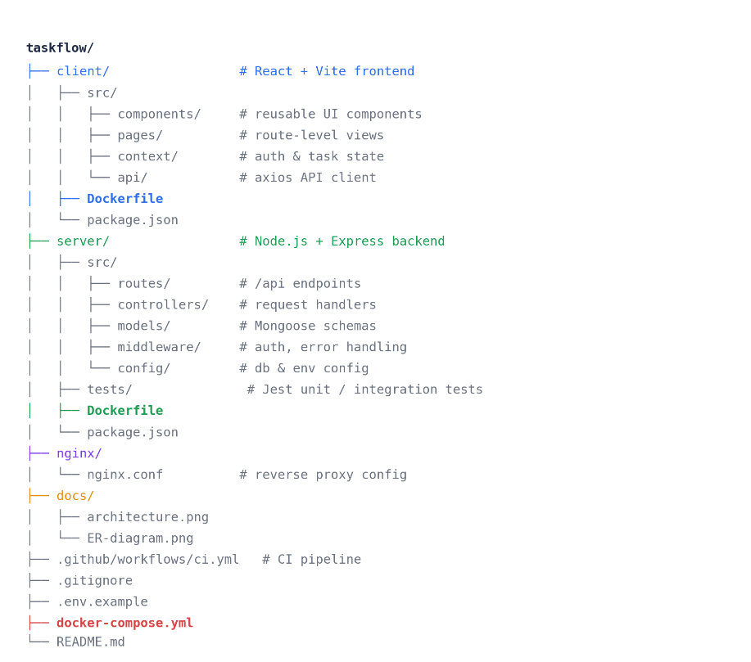
Figure 2.1 — TaskFlow repository folder structure

2.1 Purpose of Major Folders and Files

Folder / File | Purpose
client/ | React + Vite single-page application. Contains its own Dockerfile so the frontend can be built into a static bundle and served independently.
client/src/components/ | Reusable, presentational UI components (buttons, task cards, modals).
client/src/pages/ | Route-level views such as Login, Dashboard, and Project Board.
client/src/context/ | React Context providers for authentication state and shared task state.
server/ | Node.js + Express REST API. Contains its own Dockerfile so the backend can be containerized separately from the frontend.
server/src/routes/ | Defines the /api endpoint URLs and maps them to controllers.
server/src/controllers/ | Business logic that handles each incoming request.
server/src/models/ | Mongoose schemas that define the shape of data stored in MongoDB.
server/src/middleware/ | Cross-cutting concerns such as JWT authentication and centralized error handling.
server/tests/ | Jest unit and integration tests for routes and controllers.
nginx/nginx.conf | Reverse-proxy configuration that routes browser traffic to the correct container.
docs/ | Architecture and ER diagrams referenced in this report.
.github/workflows/ci.yml | Continuous-integration pipeline that lints and tests every push and pull request.
.gitignore | Excludes node_modules, build output, and environment secrets from version control.
.env.example | Documents required environment variables without committing real secrets.
docker-compose.yml | Root orchestration file that builds and links every container as a single stack.

3. Git Repository Initialization
The project repository was initialized locally with git init and then connected to a remote GitHub repository so that multiple collaborators could push and pull changes. The steps below were followed in sequence.
- git init — creates a new, empty .git subdirectory containing all the metadata Git needs (objects, refs, HEAD) to begin tracking the project.
- Create .gitignore — before the first commit, node_modules/, .env, dist/, and build/ are excluded so dependencies and secrets are never committed.
- git add . — stages the initial project scaffold (client, server, docker-compose.yml, README) for the first commit.
- git commit -m "..." — records the staged snapshot with a descriptive message, creating the repository's root commit.
- git remote add origin <url> — links the local repository to the shared GitHub repository.
- git push -u origin main — uploads the local history and sets main to track origin/main for future push/pull operations.
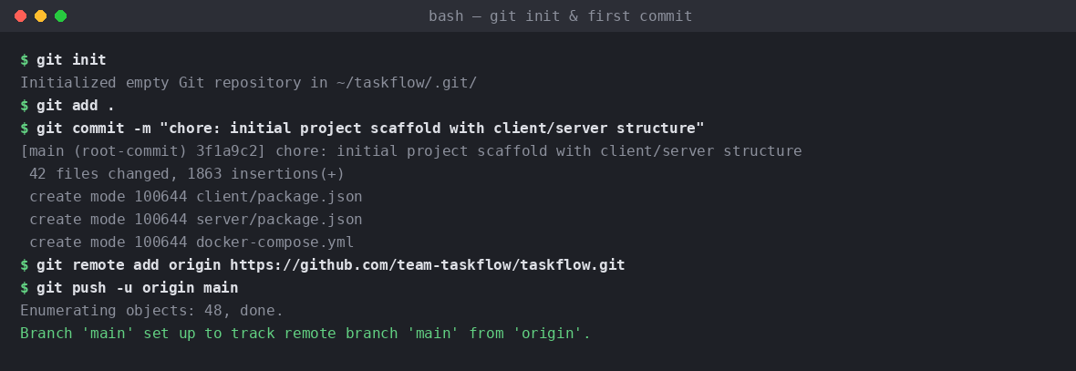
Figure 3.1 — Repository initialization and first commit

3.1 Purpose of Essential Git Files
File | Purpose
.git/ | Hidden directory holding the entire object database, refs, and history. Deleting it removes all version control.
.gitignore | Tells Git which files/folders to never track (build artefacts, dependencies, secrets).
.gitattributes | Normalizes line endings and marks binary files so diffs remain readable across operating systems.
README.md | Documents setup instructions, architecture summary, and usage for new contributors.

4. Git Branching Strategy
TaskFlow adopts a Gitflow-inspired branching model. This model was selected because the project has clearly separated phases of feature development, stabilisation, and release — the same rhythm a small collaborative team follows when shipping a containerized application in iterations.
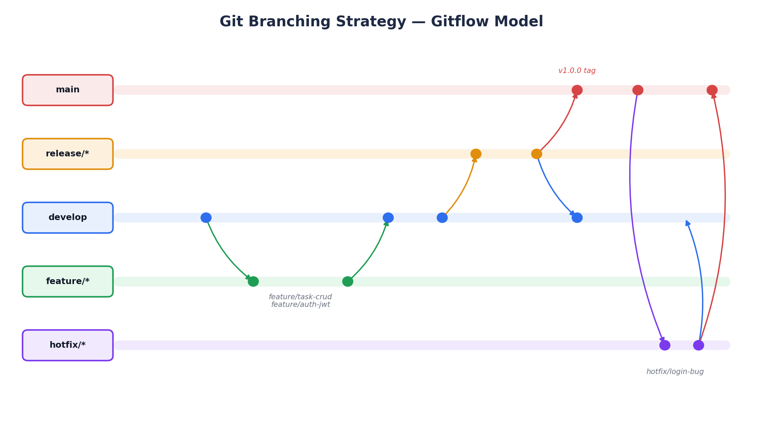
Figure 4.1 — Gitflow-style branching strategy used in TaskFlow
Branch | Purpose
main | Always reflects the latest production-ready, tagged release. Only release/* and hotfix/* branches merge here.
develop | Integration branch containing the latest delivered development changes for the next release.
feature/* | One branch per feature (e.g. feature/task-crud, feature/auth-jwt), branched from and merged back into develop.
release/* | Cut from develop when a release is being prepared; only bug fixes and documentation changes are allowed here.
hotfix/* | Branched from main to urgently patch a production defect, then merged into both main and develop.

4.1 Justification
- Parallel work: multiple contributors can build FR-3 (task CRUD) and FR-1 (authentication) simultaneously on isolated feature branches without blocking each other.
- Stability: main never receives unfinished work directly, so the container images built from main are always deployable.
- Traceable releases: release/* branches combined with annotated tags (e.g. v1.0.0) give every Docker image a reproducible, versioned source snapshot.
- Fast incident response: hotfix/* allows a production bug (e.g. a login defect) to be patched and shipped without waiting for the next full release cycle.5. Version Control Workflow
The day-to-day collaborative workflow follows eight repeatable steps, from pulling the latest integration branch to merging a peer-reviewed pull request back into develop.
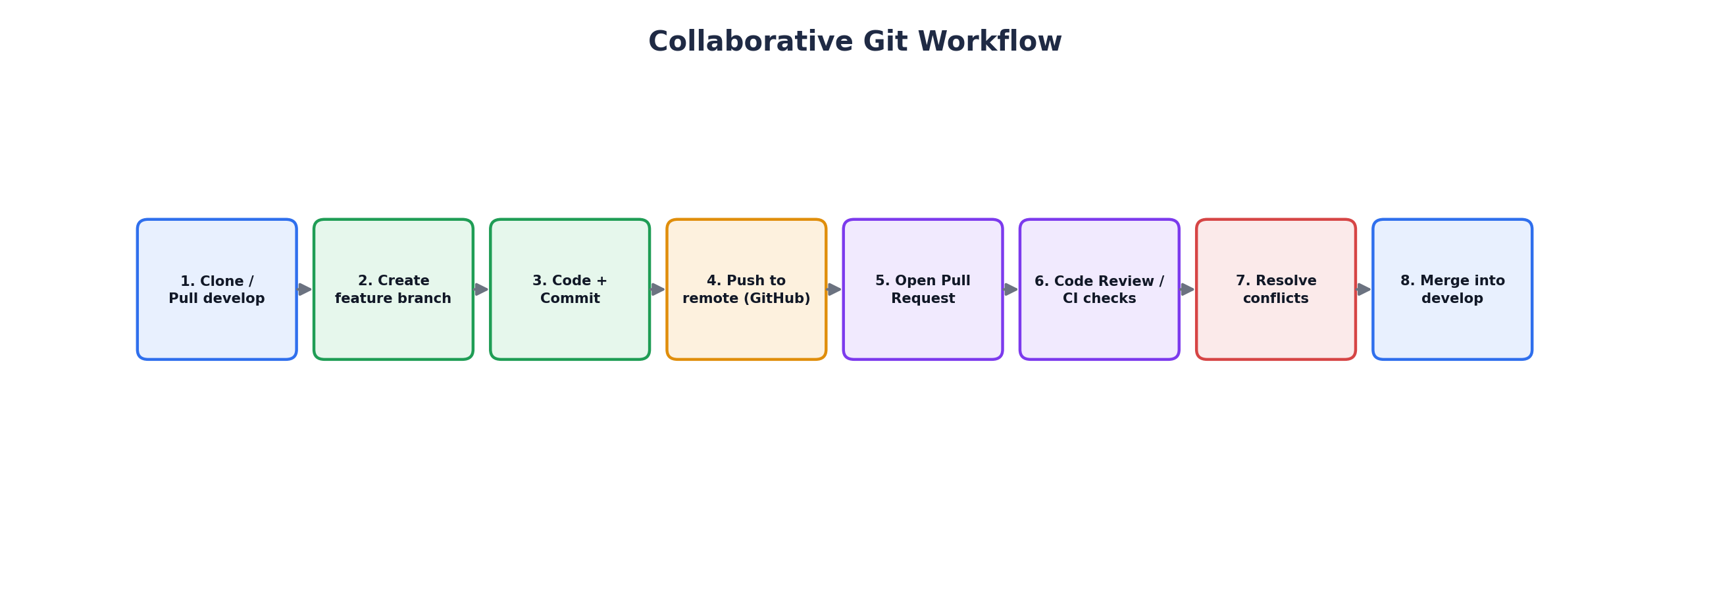
Figure 5.1 — End-to-end collaborative Git workflow

5.1 Feature Branching, Commits, and Merge
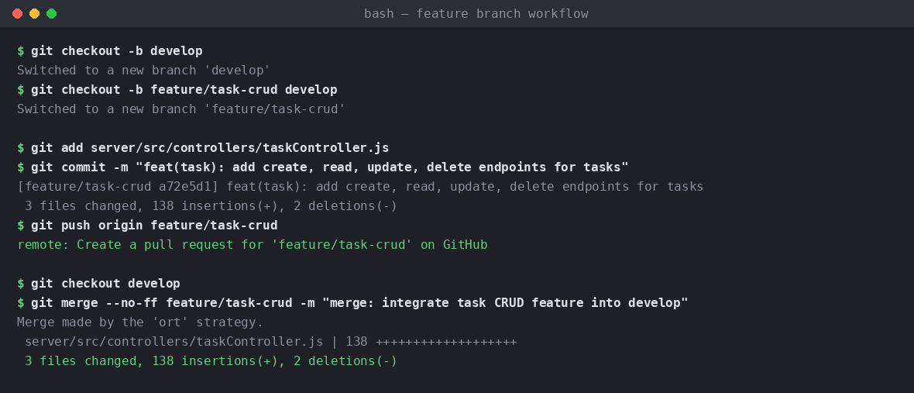
Figure 5.2 — Creating a feature branch, committing, and merging into develop
Each Git operation in the sequence above serves a specific purpose: git checkout -b creates an isolated workspace for one feature so in-progress code never destabilises develop; git add/commit records atomic, reviewable snapshots; git push publishes the branch so a pull request can be opened; and git merge --no-ff preserves the feature branch's identity in history instead of silently flattening it, which keeps the log traceable to the original pull request.

5.2 Conflict Resolution
When two branches modify the same region of a file — for example, both feature/task-crud and feature/auth-jwt registering routes in server/src/routes/index.js — Git flags a merge conflict instead of guessing. The conflicting file is opened, the <<<<<<< / ======= / >>>>>>> markers are reviewed, the correct combined code is kept, and the resolution is staged and committed to complete the merge.
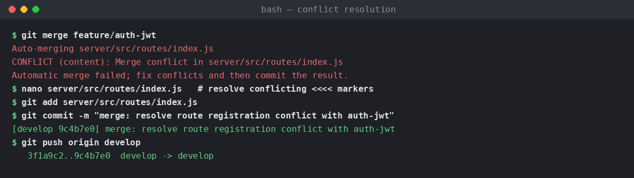
Figure 5.3 — Resolving a merge conflict in a shared routes file

5.3 Repository Synchronization
Before starting new work and before opening a pull request, contributors run git pull --rebase origin develop to incorporate the latest teammate changes and keep history linear, and git push to publish local commits. This two-way synchronization is what keeps a multi-contributor repository consistent.

6. Commit History Analysis
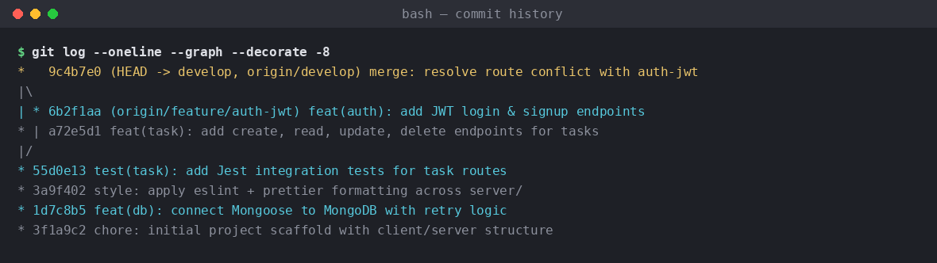
Figure 6.1 — Annotated commit history (git log --oneline --graph --decorate)

6.1 Commit Message Convention
All commits follow the Conventional Commits format, type(scope): short description, which makes the history machine-readable and easy to scan:
Type | Meaning | Example
feat | A new feature | feat(task): add create, read, update, delete endpoints for tasks
fix | A bug fix | fix(auth): correct token expiry check in JWT middleware
test | Adding or updating tests | test(task): add Jest integration tests for task routes
style | Formatting only, no logic change | style: apply eslint + prettier formatting across server/
chore | Tooling / scaffolding changes | chore: initial project scaffold with client/server structure
merge | Merge / conflict-resolution commits | merge: resolve route registration conflict with auth-jwt

6.2 How This Contributes to Maintenance
- Searchable history: git log --grep="feat(task)" instantly isolates every change related to one requirement.
- Safe reverts: because commits are atomic and scoped, git revert can undo a single feature without touching unrelated work.
- Release notes: conventional prefixes can be mechanically grouped into a changelog for every tagged Docker image.
- Onboarding: new contributors can read the log as a narrative of how the system was built, rather than a series of unlabeled snapshots.

7. Docker Environment Design

7.1 Why Docker Is Suitable for This Project
TaskFlow is composed of several independent services — a React frontend, a Node.js API, a Socket.IO real-time service, and a MongoDB database — each with different runtimes, dependencies, and lifecycles. Docker packages each service and its exact dependency tree into a portable image, so the statement “it works on my machine” is eliminated: any teammate, CI runner, or production host that can run Docker can run an identical copy of the stack. This directly satisfies the containerization emphasis of the assigned problem statement.

7.2 Components Requiring Containerization
Component | Description | Reason for Containerization
frontend | React build served by a lightweight Nginx image | Isolates Node/npm build tooling from the runtime environment
backend | Node.js + Express REST API | Needs a consistent Node.js runtime and npm dependency set
realtime | Socket.IO service | Long-running WebSocket process kept separate from the REST API
database | MongoDB | Requires persistent storage and a specific database engine version
reverse proxy | Nginx | Single entry point that routes traffic and terminates TLS

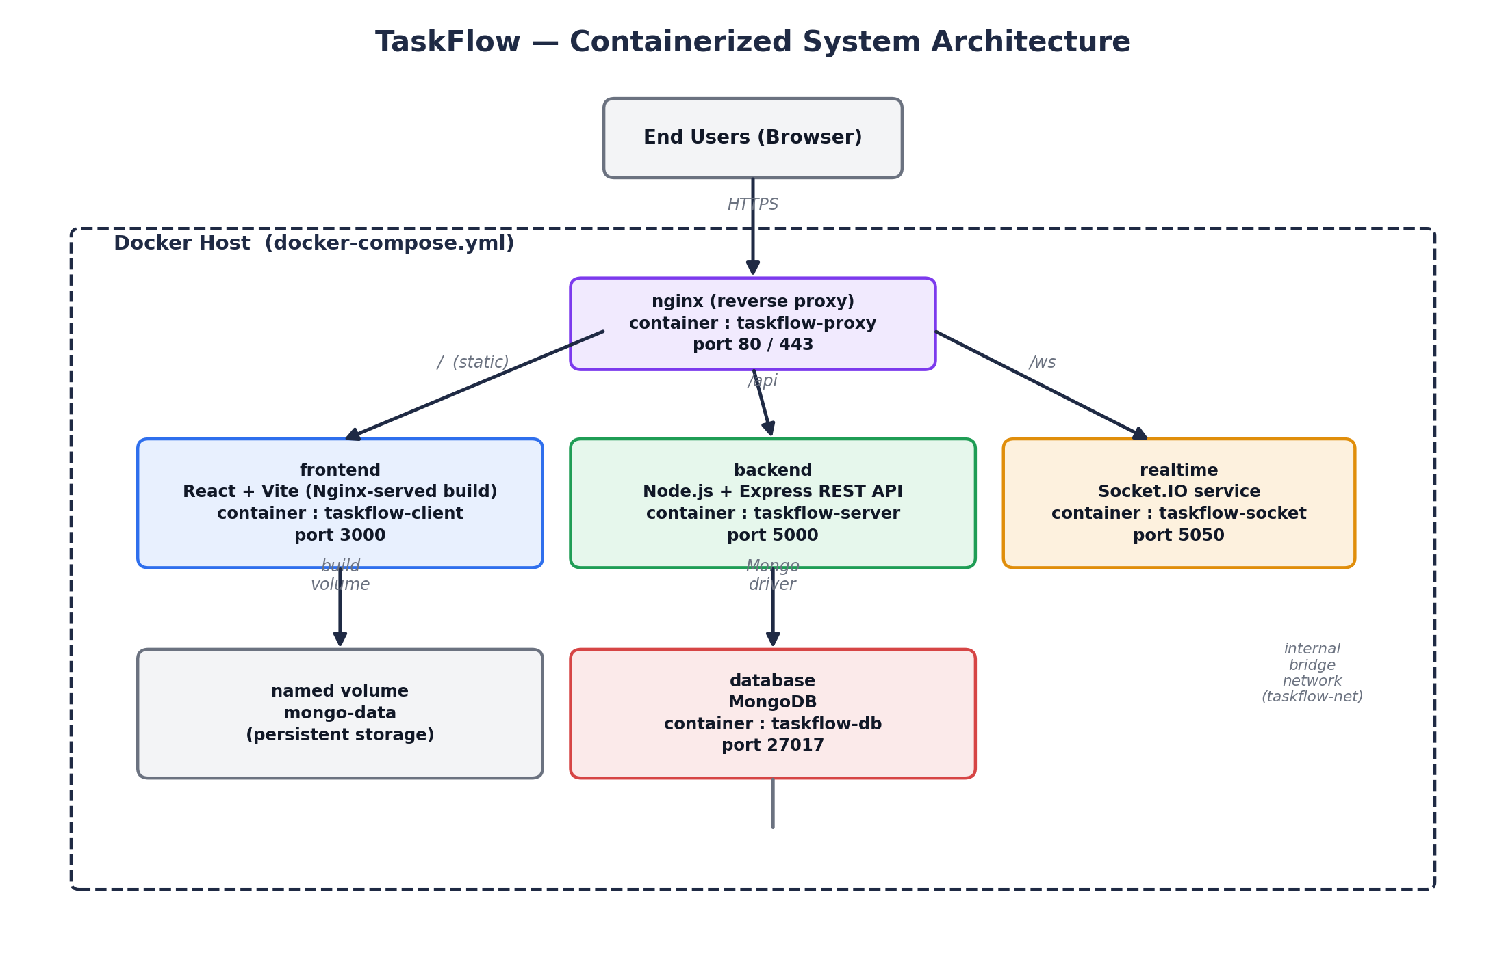
Figure 7.1 — Containerized system architecture of TaskFlow

8. Dockerfile Development
Separate, purpose-built Dockerfiles are used for the client and server so each image stays minimal and only contains what that service needs at runtime.

8.1 server/Dockerfile
FROM node:20-alpine AS base
WORKDIR /app

COPY package*.json ./
RUN npm ci --omit=dev

COPY . .

ENV NODE_ENV=production
EXPOSE 5000

HEALTHCHECK --interval=30s --timeout=5s \
CMD wget -qO- http://localhost:5000/api/health || exit 1

CMD ["node", "src/server.js"]

Instruction | Purpose
FROM node:20-alpine | Uses a small, security-patched Node.js 20 base image to minimise final image size.
WORKDIR /app | Sets the working directory inside the container for all subsequent instructions.
COPY package*.json ./ | Copies only the manifest files first so the dependency layer can be cached.
RUN npm ci --omit=dev | Installs exact, locked production dependencies for a reproducible build.
COPY . . | Copies the remaining application source code into the image.
ENV NODE_ENV=production | Configures Express and dependent libraries to run in production mode.
EXPOSE 5000 | Documents the port the Express server listens on.
HEALTHCHECK | Lets Docker/Compose detect an unresponsive API container and restart it automatically.
CMD [...] | Defines the default command that starts the Node.js server when the container runs.

8.2 client/Dockerfile (multi-stage build)
# ---- Stage 1: build the static React bundle ----
FROM node:20-alpine AS build
WORKDIR /app
COPY package*.json ./
RUN npm ci
COPY . .
RUN npm run build

# ---- Stage 2: serve with a lightweight web server ----
FROM nginx:1.27-alpine
COPY --from=build /app/dist /usr/share/nginx/html
COPY nginx.client.conf /etc/nginx/conf.d/default.conf
EXPOSE 3000
CMD ["nginx", "-g", "daemon off;"]

Instruction | Purpose
FROM node:20-alpine AS build | First stage: a throwaway Node.js environment used only to compile the React app.
RUN npm run build | Produces an optimised, static production bundle in /app/dist.
FROM nginx:1.27-alpine | Second stage: a fresh, minimal Nginx image used for the runtime container.
COPY --from=build ... | Copies only the compiled static files from stage 1 — no Node.js or source code ships in the final image.
EXPOSE 3000 / CMD | Serves the static bundle on port 3000 when the container starts.

Why multi-stage?
Multi-stage builds keep the final client image small (only Nginx + static files) by discarding the Node.js toolchain and node_modules used solely to build the bundle.

9. Docker Compose Design
Docker Compose orchestrates all five containers as a single stack, wiring up networking, persistent storage, environment variables, and startup dependencies declaratively in one docker-compose.yml file.
version: "3.9"

services:
client:
build: ./client
container_name: taskflow-client
networks: [taskflow-net]
depends_on: [server]

server:
build: ./server
container_name: taskflow-server
env_file: .env
environment:
- MONGO_URI=mongodb://db:27017/taskflow
networks: [taskflow-net]
depends_on:
db:
condition: service_healthy

socket:
build: ./server
command: node src/socketServer.js
container_name: taskflow-socket
networks: [taskflow-net]
depends_on: [db]

db:
image: mongo:7.0
container_name: taskflow-db
volumes:
- mongo-data:/data/db
networks: [taskflow-net]
healthcheck:
test: ["CMD", "mongosh", "--eval", "db.adminCommand('ping')"]
interval: 10s
retries: 5

proxy:
image: nginx:1.27-alpine
container_name: taskflow-proxy
ports: ["80:80"]
volumes:
- ./nginx/nginx.conf:/etc/nginx/nginx.conf:ro
networks: [taskflow-net]
depends_on: [client, server, socket]

networks:
taskflow-net:
driver: bridge

volumes:
mongo-data:

9.1 Services, Networking, Volumes, and Dependencies
Services
Five services — client, server, socket, db, proxy — each built from its own Dockerfile or a pinned public image, so every part of the stack is versioned and reproducible.
Networking
All services join a single user-defined bridge network, taskflow-net, so containers can reach each other by service name (e.g. the API connects to mongodb://db:27017) without exposing internal ports to the host.
Volumes
A named volume, mongo-data, persists MongoDB's data directory outside the container lifecycle, so database contents survive container restarts and rebuilds.
Environment Variables
Sensitive and environment-specific values (JWT secret, Mongo URI, API keys) are injected via env_file: .env, keeping secrets out of the image and out of version control.
Dependencies
depends_on with a service_healthy condition ensures the API only starts once MongoDB has passed its health check, preventing connection-refused failures on startup.

10. Container Deployment and Testing

10.1 Building and Starting the Stack
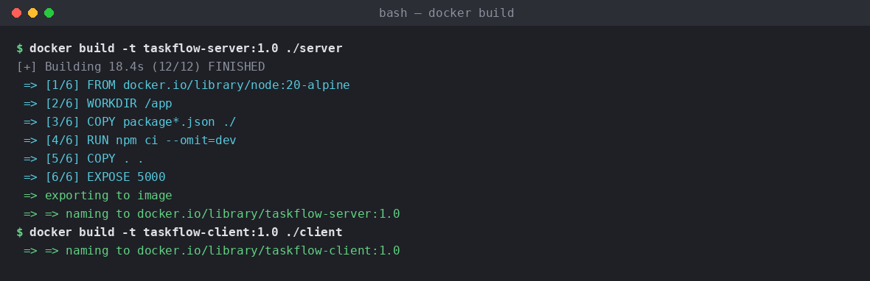
Figure 10.1 — Building the server and client images
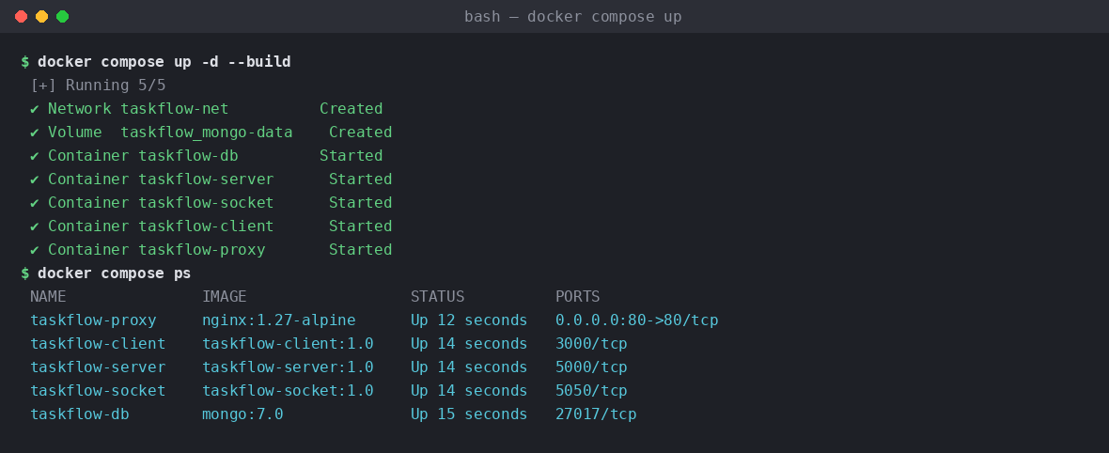
Figure 10.2 — Starting the full stack with docker compose up -d --build

10.2 Testing Procedure and Evidence
After the stack is running, three levels of verification confirm the application works end-to-end: an HTTP health check against the Nginx-proxied API, live container log inspection, and the automated Jest test suite executed inside the running server container.
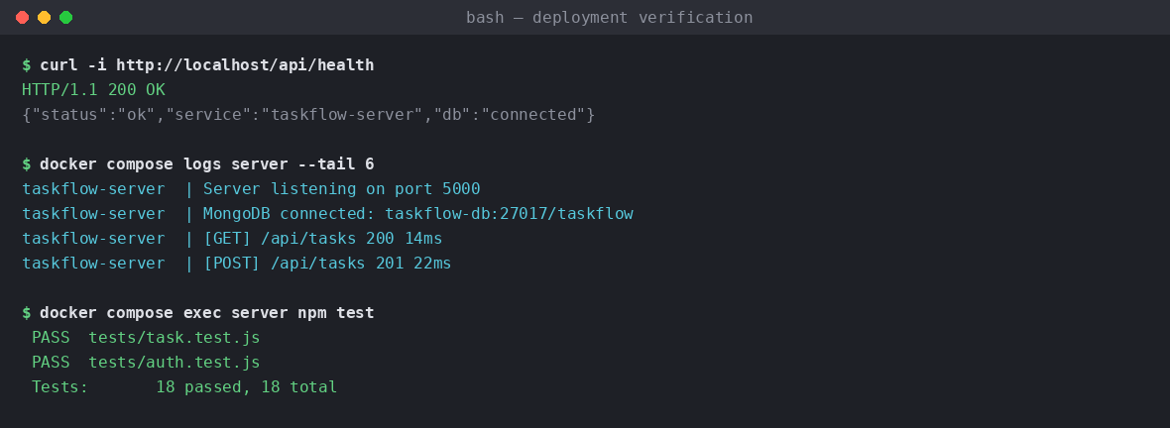
Figure 10.3 — Health check, container logs, and automated test run
Test | Command / Action | Expected Result
Health check | curl http://localhost/api/health | HTTP 200 with { status: "ok", db: "connected" }
Manual smoke test | Create a project and a task via the UI | Task appears instantly on a second browser tab (Socket.IO)
Automated tests | docker compose exec server npm test | 18/18 Jest tests passing
Persistence check | docker compose restart db | Previously created tasks remain after restart (named volume)
11. Benefits of Git and Docker
Dimension | How Git & Docker Help TaskFlow
Collaboration | Feature branches and pull requests let multiple developers work on task management, authentication, and real-time updates in parallel without overwriting each other's work.
Version Management | Every change is traceable to a commit, author, and reason, and any previous state of the codebase — or of a Docker image — can be reproduced exactly.
Portability | A Docker image built once runs identically on a developer laptop, a CI runner, or a cloud VM, removing environment-specific bugs.
Deployment | docker compose up replaces a long list of manual setup steps with a single reproducible command, shortening deployment time from hours to minutes.
Scalability | Stateless containers such as server and socket can be horizontally scaled (e.g. docker compose up --scale server=3) behind the Nginx proxy as load grows.
Maintainability | Isolated services with clear Dockerfiles and a documented branching model make it easy for new contributors to understand, extend, and safely modify the system.

12. Challenges and Improvements

12.1 Challenges Encountered
Challenge | Description
Merge conflicts on shared route files | Two feature branches both edited server/src/routes/index.js, causing a conflict that required manual reconciliation (see Section 5.2).
Container startup ordering | The API container occasionally started before MongoDB was ready to accept connections, causing an initial connection error.
Image size | The first version of the client image included the full Node.js toolchain, producing an unnecessarily large runtime image.
Secret management | Early drafts risked committing the .env file with database credentials directly to Git.

12.2 Improvements and Future Enhancements
- Resolved container startup ordering by adding a healthcheck to the db service and a depends_on: condition: service_healthy on the API — eliminating the race condition.
- Reduced client image size using a multi-stage Dockerfile, dropping the Node.js build layer from the final Nginx-based image (Section 8.2).
- Added .env to .gitignore and introduced .env.example so secrets are documented but never committed.
- Future: introduce a full CI/CD pipeline (GitHub Actions) that automatically builds, tests, and pushes Docker images on every merge to main.
- Future: add branch-protection rules requiring at least one review and passing CI checks before a pull request can merge into develop.
- Future: adopt Kubernetes or Docker Swarm for automated scaling and self-healing once the user base grows beyond a single-host deployment.

Conclusion
This assignment implemented TaskFlow, a collaborative full-stack task management application, to satisfy the CO3 problem statement's emphasis on containerization, version control, and collaborative development. A Gitflow-inspired branching strategy enabled safe, parallel feature development with a traceable, conventionally-formatted commit history, while purpose-built Dockerfiles and a single Docker Compose configuration containerized the frontend, backend, real-time service, database, and reverse proxy into one reproducible, portable stack. Together, these practices demonstrate how modern version-control and containerization tooling directly translate into faster collaboration, safer releases, and consistent deployments — the core outcomes expected of CO3.

References
- Git Documentation — https://git-scm.com/doc
- GitHub Docs, "About pull requests" — https://docs.github.com/pull-requests
- Docker Documentation — https://docs.docker.com
- Docker Compose Specification — https://docs.docker.com/compose/compose-file/
- Node.js Documentation — https://nodejs.org/en/docs
- MongoDB Documentation — https://www.mongodb.com/docs
- Conventional Commits Specification — https://www.conventionalcommits.org
- Driessen, V. "A

